The Nortons' Old Hall, Gardens and Deer Park at Rylstone

History of the Old Hall and gardens

Depiction of Nortons' Old Hall by Birket Foster in The White Doe of Rylstone by William Wordsworth. (1867 edition published by Bell and Dandy. Digitised by Google and available on the University of Illinois website).

John Norton of Norton-Conyers came to hold Rylstone hall and manor when he married Ann Radcliffe, daughter of William Radcliffe and great grand-daughter of John de Rillestone, on 12 Jan.1492/1493. He is said by Whitaker (1878) and others to have rebuilt the pre-existing hall of the de Rillestones and Radcliffes soon after his marriage near the end of the 15th century. His eldest son, Sir Richard Norton inherited the property and manor, but then lost both to the Crown as a penalty for his and his family's involvement in the Uprising of the North in 1569 (Hicks, 2004; Rylstone website; Percy, 1765).

The Crown ceded the Norton lands to the Cliffords in 1603, who then progressively sold them off or rented them out. Remaining parts of the Clifford's Rylstone estate eventually passed down to the Devonshire family who still own a good deal of land in the parish, including Old Hall Farm, on which the Old Hall and its grounds are sited.

The Old Hall was said never to have been lived in after Richard Norton's time, and gradually fell into disrepair and then ruin. However, Wordsworth imagined that Emily the fabled, (but unproven) last surviving member of the Norton family lived there alone for some years after others had all left or died. He poetically described it in the 'White Doe of Rylstone':

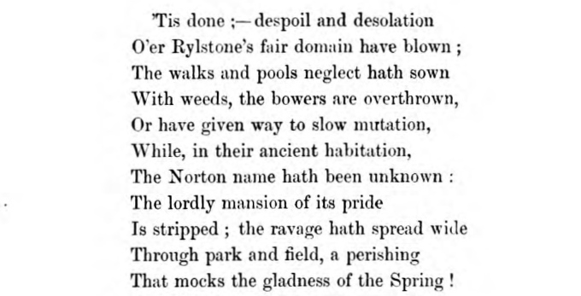

Mary Stoney, using material from Whitaker's History of Craven and Raistrick's Old Yorkshire Dales, describes the Old Hall as follows:

'The foundations of this hall are now, in part, covered by the 17th century farm and its out-buildings, together with the church and church-yard, all enclosed, but not a stone remains.

It was still standing in the 18th century, and had mullioned casements and pointed arches, square turrets, capacious fire-places and clustered chimneys. Near the hall was a pleasure ground with topiary works, fish ponds and an island in one of them, and mounds for archery butts. There was a little enclosed meadow-land near the hall, but the greater part lay open in the town field, including the arable land. The whole township was ranged by about 130 red deer, the property of the Lord of the Manor'.

The location of the Old Hall is shown below on the 1853 Ordnance Survey map of the area and only the site remains, although the YDNPA (undated), using material from Moorhouse (2003), states that, 'The ruins of the Norton family seat were demolished some time in the 20th century'.

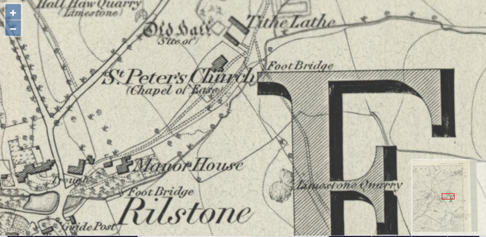
The YDNPA went on to say that, 'Only the earthworks of the extensive water gardens that once lay to the east of it survive. Survey and aerial photographs reveal that there was once a square lake [shown in photograph below] with a central bird island'. Rylstone Old Hall grounds are listed on the Historical Environmental Record (MYD3942; SD973589).

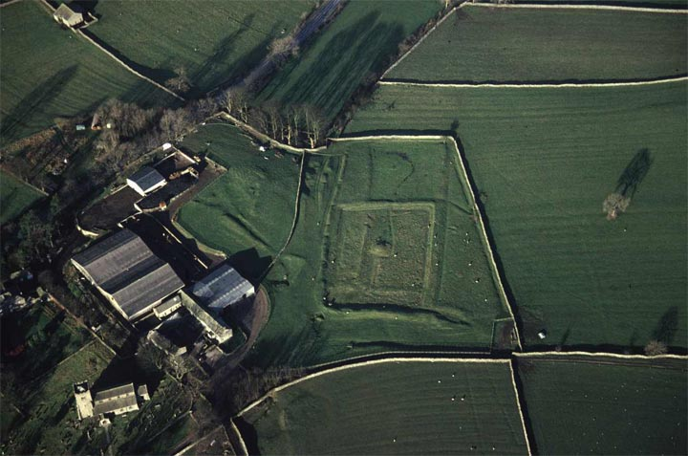
Stone barns and farm-house
Old fish pond in Old Hall gardens
Location of Old Hall
YDNPA, 2004 (046/13).

Humphrey Bolton took a more recent photograph of the pond in the grounds in 2009, and stated that, 'This is an ancient fishpond, presumably part of the lands of Rylstone Old Hall. It is shown dry on OS maps of the late 20C, but has now been re-made, for ducks as well as fish'. However, it is not clear that there is actually any fish now in this pond; only visiting ducks and wildlife!

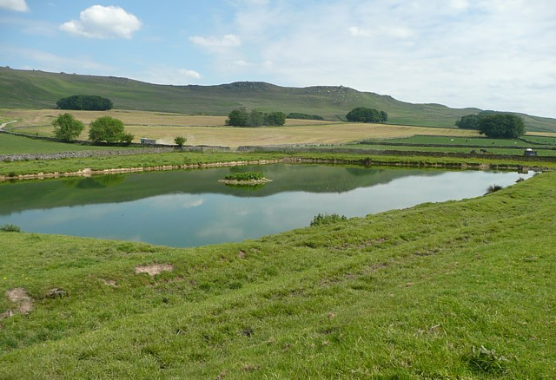
Old fish pond, Old Hall Farm. © Copyright Humphrey Bolton
A project visit to the Old Hall site

Old Hall Farm, its barns and out-buildings, now cover the site of the old manor house and the Rylstone Project team visited the site in Spring 2013 at the invitation of the Caygill family who have farmed there for many years. We were shown some piles of worked stones, behind the barns, that were said to be from the Old Hall. We were also able to take a detailed look at the barns, some parts of which are quite ancient. Alison Armstrong, a house historian who was with the team, made the following notes about them:

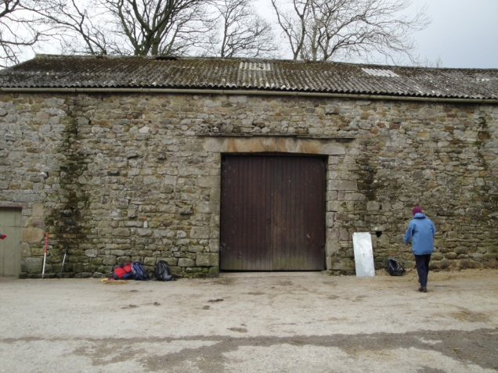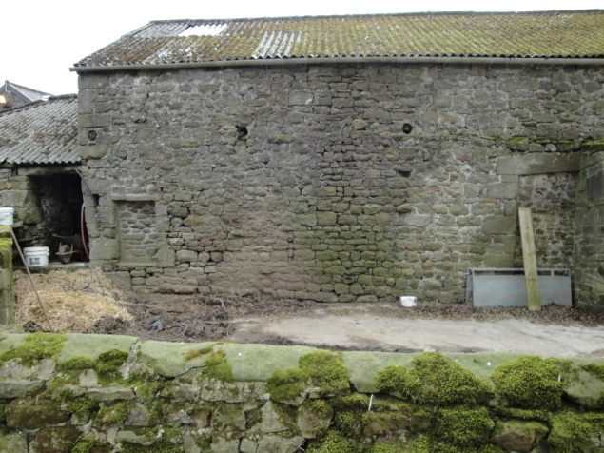
South Barn, Old Hall Farm

'These [the barns] are of interest as likely to be part of the farm buildings of the old hall. The hall was demolished in 18th C and it seems its timbers and perhaps other materials were re-used in the 18th C. The barns are arranged around a quadrangle-like fold yard of 'model farm' style (a form perpetuated by Chatsworth estate at Barden). A 'tithe barn' was recorded here by OS in 1852 but that may be the site of the walled livestock fold now.

The south barn is long (7 bays?) There are cart doors on the N and S. The S has two cruck timbers reused. The building appears to have lower rooflines and buttresses support the S wall.
The west range was originally Georgian open-sided cow sheds into the fold yard. These openings are now blocked. The hipped roof at the SW corner looks like a horse gin for a threshing machine?
The north barn is also very long and runs up hill. The dwelling at the east end appears to be of medieval foundation with medieval stonework. The barn is full of re-used timbers including cruck pieces but also paired rafters (14th-16th C?); several wallplates from a roof with seatings cut for rafters and dovetailed joints for tie beams; old floor beams with cuts for joists.

At the close of our visit, Alison concluded that, 'it is likely that the old hall became a source of recycled timber and stone for the rebuilt 18th C barns'.

The old deer park

In medieval and early modern England a deer park was an enclosed area containing deer which were preserved for hunting. It was bounded by a ditch and bank, with a wooden park pale on top of the bank, or by a stone or brick wall. The ditch was on the inside, increasing the effective height. The deer park was often in an area within a medieval hunting forest

The Manor of Rylstone was associated with hunting from at least the 13th century. According to the Early Yorkshire Charters (Clay, 1947), on the 28th December 1257, Eustace de Rilston ll was granted free warren in his demesne lands in Rilston by King Henry lll. The free warren was confirmed for Richard Fauval the Lord of the Manor and Emma his wife in 1327. Free warren meant that no one was allowed to trespass the Lord’s lands to hunt for wild animals. The legal implications were complex because no one might hunt the fox or hare into warren land, but to follow the deer into the warren was not considered to trespass as deer were 'beasts of the forest' (McGurk, 1970).

Hunting deer was always the pursuit of the upper echelons of society in the medieval Yorkshire Dales, but the right to hunt vermin and lesser beasts was sought after too. The survey of 1603 for the attainder of the estates of Richard Norton, after his part in The Rising of the North, specifies 130 red deer, which became the property of Sir Stephen Tempest of Broughton, as quoted in Whitaker’s book on Craven.

Whitaker is further quoted by Villy, who investigated the site of Norton Tower, and wrote a detailed report in 1915, which stated that:

'A dispute began during the tenure of Rylstone by the first Norton (John) to hold lands hereabouts. It concerned the hunting rights in the township, both Norton and the then Clifford of Skipton claiming free warren. In 1530 a subpoena was then directed to the first Earl of Cumberland from the court in York. In the latter part of Henry Vlll’s reign, the following passed from the Privy Council to the Earl of Shrewsbury, Lieutenant-General in the North: "whereas complaint has lately been made to the Queen’s Highness Catherine Parr) that my Lord of Cumberland pretending right of forest within certain grounds belonging to John Norton where the said Norton does claim free warren, hath now of late not only intruded there, but caused also sundry of his servants to cast down the hedges and dykes".

Among the testimony of seven witnesses for the Clifford side is Lancelot Marton Esq. of Eshton who said, “that he was a boy and together with his father he saw the keepers of Skipton Forest hunt and chase deer out of the grounds of Rylstone... till now of late that Master Norton has walled his grounds of Rylstone, where the foresters were wont to walk and to draw my Lord of Cumberland’s deer into his ground he has made a wall on a high ridge beside a quagmire, and at the end of the wall he has railed the ground, so that it is a destruction to my lord’s deer so many as come”. Master Marton’s testimony is evidence that a wall was built. Whitaker p.252 says the Cliffords themselves subsequently enclosed the same ground, with part of the fell above for a park'.

Reverend Bury, who was vicar of St. Peters Church, Rylstone from 1839 to 1875 writes:

'Rilston Fell yet exhibits a monument of the old warfare between the Nortons and Cliffords. On a point of very high ground, commanding an immense prospect and protected by two deep ravines, are the remains of a square Tower expressly said by Dodsworth to have been built by Richard Norton. The walls are of strong grout work, four feet thick: it seems to have been three stories high. Breaches have been industriously made in all the sides, almost to the ground, to render it untenable.

The Keepers of the Earls of Cumberland complained against Norton for his contrivance to impound the deer; and it is curious enough that after almost three centuries vestiges of this work should yet remain. On the plain summit of the hill are the foundations of a strong wall stretching from the SW to the NE corner of the tower; and to the edge of a very deep glen. From this glen a ditch, several hundred yards long, runs S to another deep and rugged ravine. On the N and W, where the banks are very steep, no wall or mound is discoverable, paling being the only fence which would stand on such ground. And this is the pound complained of.

From the Minstrelsy of the Scottish Border Vol. 1.p4 it appears that such pounds for deer, sheep etc were far from being uncommon in the South of Scotland. The principle of them was something like that of a wire mouse-trap. On the declivity of a steep hill, the bottom and sides of which were fenced so as to be impassable, a wall was constructed nearly level with the surface and the outsides yet so high within that without wings it was impossible to escape in the opposite direction. Care was probably taken that these enclosures should contain better feed than the neighbouring parks or forests and whoever is acquainted with the habits of these sequacious animals [ones who follow or endeavour to follow a role model] will easily conceive that if the leader was once tempted to descend into the snare, a herd would follow to recover which there were probably more frays than lawsuits. After Rylstone came into possession of the Cliffords, the same ground, with part of the fell above, was enclosed for a walled park, of which it still retains the name and the name only'.

He seems to be getting his information from Whitaker. Villy quotes Whitaker with exactly the same description as given by Rev. Bury, but Villy disagrees with Whitaker’s interpretation as a deer pound, as described above. Villy reasons that, 'the eastern entrenchment is built on a gentle slope not a steep one, the fosse(ditch) is outside or up the slope, the vallum (earthwork) and wall being inside or downhill so that if the work was constructed to bar passage, that passage was inwards not outwards; and there are signs of an entrance which could only have been constructed for defensive purposes'. The likelihood then seems to be that the eastern wall at any rate was put up by the Nortons, probably in connection with deer, and that it was defensive in design to guard against raids from Skipton.

Brigantia Archaeological practice produced a report for Mr Jim Caygill and the Yorkshire Dales National Park Authority in February 2012 on Norton Tower and they comment on the deer park as follows:

'The first John Norton was engaged in litigation with his superior Lord the Earl of Cumberland (Clifford) over hunting and warrening rights, and this dispute was continued by his son. A walled park was created on the high ground to the east of the site, supposedly after the land had come into the possession of the Cliffords.

It seems likely that the old wall to the north of the tower represents the boundary of the deer park which was established in the 17th century after the estate had been acquired by the Cliffords. This is suggested by the massive scale of the wall, and by the hollow which runs along its western edge and which can be seen as the remains of a ha-ha. If this is the case, the creation of the park may be seen as the formal enclosure of an existing hunting ground, in which the Tower played an important part. It is likely that it served as a guard-house for the hunting grounds which were, of course, the subject of considerable dispute- but it was perhaps equally important as a banqueting house, important in the complex and competitive protocols of hospitality involved in Tudor hunting. Interpretation of the landscape south of the Tower as a deer park is supported by the presence of three pillow mounds. Their identification with artificial coney [rabbit] warrens is well established. These warrens were especially associated with deer parks'.

(See Williamson, T (2006) for more on pillow mounds and rabbit warrens).

The Rylstone Group has tried to establish the perimeter of the deer park during walk-over surveys, and we found elements of an old enclosure with double ditch above the Old Hall grounds and towards Rylstone Fell. This does not entirely accord with the above reports of a more extensive deer park, the southern edge of which was beyond Norton Tower. It may be that the Nortons had a closer-by enclosure for deer, ready for culling for the table.
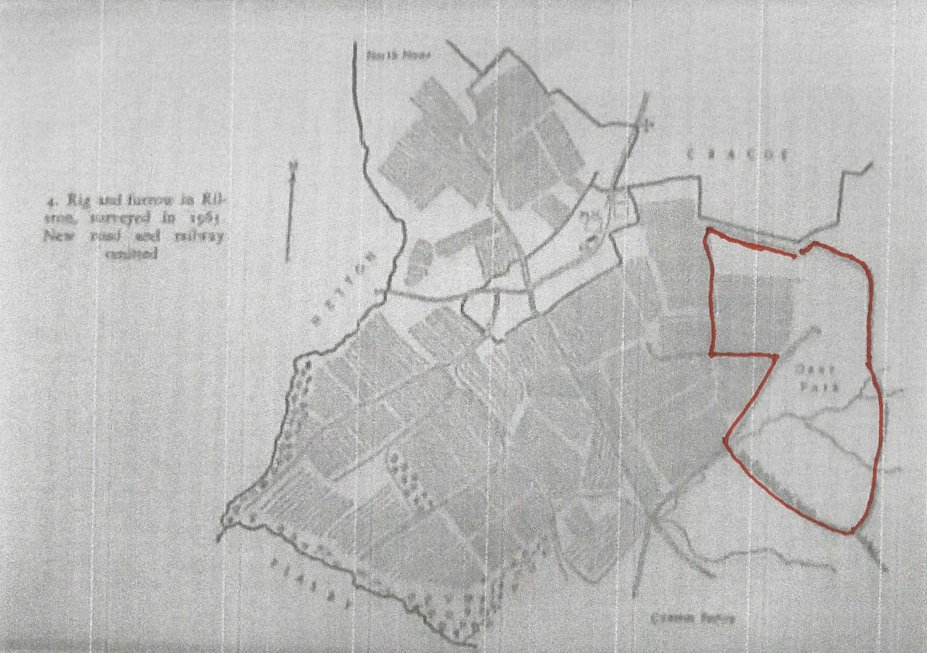
Base drawing from Raistrick's (1967) Old Yorkshire Dales. Possible Deer Park outlined in red.

References

Brigantia Archaeological Practice. (2012). Archaeological survey of Norton Tower, Rylstone, Craven (Yorkshire Dales National Park) and associated landscape. A report to Mr Jim Caygill and the Yorkshire Dales National Park Authority.

Bury, W. (1839-875). Unpublished Scrapbook of Reverend Bury. Vicar of St Peter’s Church, Rylstone. See page of transcripts from Rev. Bury's scrapbook on Rylstone Project website.

Clay, C. T. (1947, repub. 2013). Early Yorkshire Charters. Volume 7:Honour of Skipton, Rillston Fee. pp. 266 and 268. Cambridge University Press.

Dodsworth, R. (1585–1654). An English antiquarian who prepared a series of transcripts - often fragmented - on Craven. Frequently referred to by Whitaker as a source in his History of Craven. See full reference below.

Hicks, M. (2004). Norton, Richard [called 'Old Norton'] (d. 1585), Rebel. In: Oxford Dictionary of National Biography. Published online since September 2004. Available at: http://www.oxforddnb.com.

McGurk, J.J. (1970). A Dictionary of Mediaeval Terms. St. Mary’s College of Education Strawberry Hill Middlesex. Reigate Press.

Moorhouse, S. (2003) 'The anatomy of the Yorkshire Dales: deciphering the medieval landscape' in Manby, T. G. et al (Eds.) (2003). The Archaeology of Yorkshire: an assessment at the beginning of the 21st century. Yorkshire Archaeological Society. Occasional Paper No 3 pp. 298-362.

Parker, J. P. (1894). A Glossary of Terms Used in Heraldry. Last modified by Trigg, J. in 2004. Available at: https://www.heraldsnet.org.

Percy, T.(Ed.) (First pub. 1765). Ballad in 'The Rising of the North' in Reliques of Ancient English Poetry. Book III, pp. 245-250. Republished on-line by the Ex-classics Project, 2016 and available at: http://www.exclassics.com.

Raistrick, A. (1967). Chapter Two: 'Discovering A Village' in Old Yorkshire Dales. Newton Abbot: David and Charles.

Rylstone Project Team (2016). The Norton Family. Project website.

Scott, W. (1802). Minstrelsy of the Scottish Border. Vol. 1. p.4. Now available to download from the Project Guttenberg website at: www.gutenberg.org/wiki/United_Kingdom_

Stoney, M. (1979). 'The Nortons of Rylstone'. Cracoe Parish Magazine. February (Part 1) and April (Part 2).

Villy, F. (1915). 'The Site of Norton Towers'. The Journal of the Bradford Historical and Antiquarian Society. October 1915. MD Bradford Antiquaries.

Whitaker, T.D. (3rd Edition, 1878, republished 1973). The Deanery of Craven. Volume 2, pp. 517-528. Menston: The Scolar Press Ltd.

Williamson, T. (2006).The Archaeology of Rabbit Warrens. p. 7.Princes Risborough, Bucks: Shire Publications Ltd.

Yorkshire Dales National Park Authority (undated). 'Rylstone Hall Gardens' in the Parks and Gardens section on the Out of Oblivion: A Landscape Through Time website at: http://www.outofoblivion.org.uk/record.asp?id=427.

