Boundary Section 8:

Sandy Beck Bar to Confluence of Wash Fold and Calton Gill Becks

Site of old Tilery
Scale House
Wash Fold Beck
Old well
Toll House at Sandy Beck Bar
Swindon quarry to Skipton railway line
Calton Gill Beck

Highlights
- This section of boundary initially follows Sandy Beck (which flows South) by the B6265 main road from Skipton to Grassington. It then winds it way, North West through some low lying fields and past Scale House. Earthworks show that there was an old road on the south side of the house which was re-routed later further east and away from the house to the present Sandy Lane - the old track-way from Rylstone to Skipton. North of Scale House, the boundary passes Low Laithe Barn to the confluence of Calton Gill Beck, which rises on the Eastern slopes of Flasby Fell, and Wash Fold Beck, which rises on Rylstone Fell. These then flow North West into Hetton Beck.

- Between Sandy Back bar and Scale House, there is not a great deal to note except for a way marker and old well as shown in the photographs below.

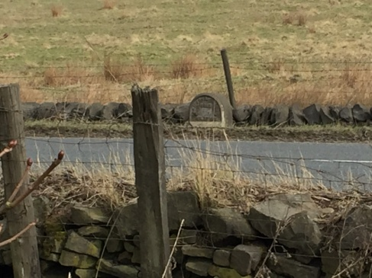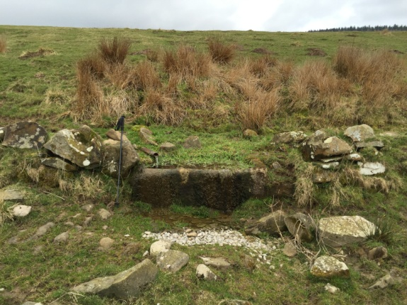
Old way marker on B6265 Old well above B6265

- Scale House, situated further up the B6265 is a notable, Grade 2 listed building of fine proportions. It was once part of a sizeable estate with Scale House Farm, several cottages, and a considerable amount of land around Rylstone. It was the family home of the Standevan family who were woollen manufacturers for much of the 20th century. The house is now split up into apartments and the other buildings and land have been sold off.

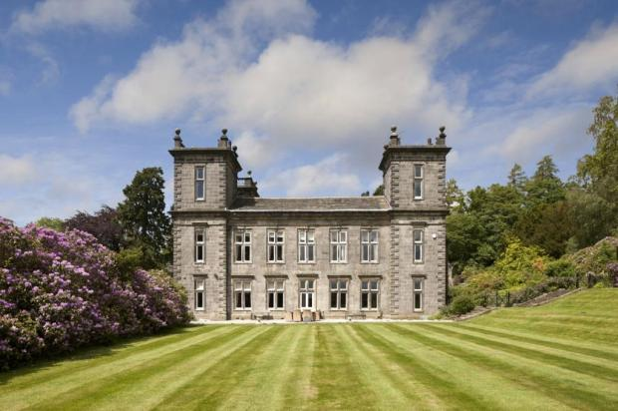

The original Scale House was a Norse settlement just beyond the confines of the Anglican settlement and at the southern end of Rylstone township. The name, 'Scale' is Norse for clearing.

About 1609 the well-to-do Watkinson family bought the property from the Earl of Northumberland. It is likely the property was rebuilt soon after, and at this time Scale House consisted of a mansion and farmstead which in the 17th century was occupied by George Watkinson and his two brothers who became Quakers in the mid 1650s. An early Quaker meeting house was located here. It was sold by the Watkinsons in 1704 and enlarged by the Morley family, who were gentry farmers and landowners in the early 18th century. It was then extensively extended and renovated in the later 18th and 19th centuries by a Captain Blake.

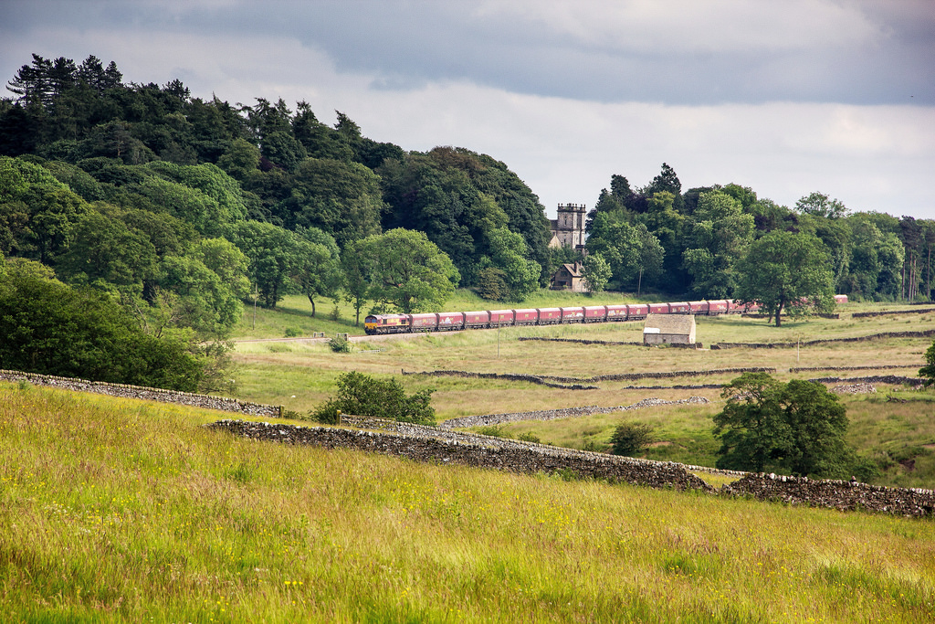
Image of the Swindon quarry train passing Scale House with
Low Laithe Barn in the foreground.

- In the North East of this boundary area the site of an old tilery or tile kiln has been located. The tile kiln was used to manufacture tiles for drainage and therefore for the improvement of the rough pastures after the enclosure of common land. No documentation of the tile kiln has been discovered, but it is thought that it would have been in operation between 1790 and 1850. A group led by Dr. Raistrick excavated the site in 1971 (see photograph below). They found a heap of fragments of brick and drainage tiles with some intact and a brick building with thick walls, and arched openings which were the firing holes for the tiles.

